There is a brick wall in front of you. The wall is rectangular and has several rows of bricks. The bricks have the same height but different width. You want to draw a vertical line from the **top** to the **bottom** and cross the **least** bricks.

The brick wall is represented by a list of rows. Each row is a list of integers representing the width of each brick in this row from left to right.

If your line go through the edge of a brick, then the brick is not considered as crossed. You need to find out how to draw the line to cross the least bricks and return the number of crossed bricks.

**You cannot draw a line just along one of the two vertical edges of the wall, in which case the line will obviously cross no bricks.**

**Example:**

**Input:** [[1,2,2,1],

[3,1,2],

[1,3,2],

[2,4],

[3,1,2],

[1,3,1,1]]

**Output:** 2

**Explanation:**

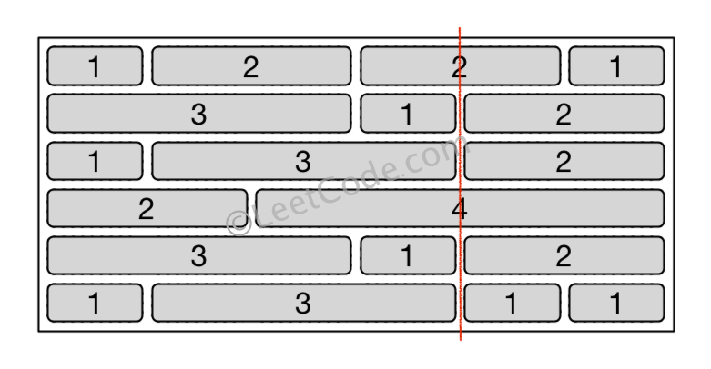

**Note:**

1. The width sum of bricks in different rows are the same and won't exceed INT_MAX.
2. The number of bricks in each row is in range [1,10,000]. The height of wall is in range [1,10,000]. Total number of bricks of the wall won't exceed 20,000.